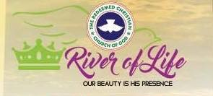

5617 54th Ave. Riverdale, MD 20737

To Whom It May Concern:

Re: Pastor Maynor & Itzel Trochez

I write this letter to recommend the above named couple and ministers of the gospel. They served faithfully as pastors in our multicultural congregation and ministry. They also worked diligently founding and establishing the Latino ministry, our bookstore, building maintenance/beautification and so much more before the Lord called them to itinerary/missionary ministry. They have been called to impact the body of Christ with extravagant worship, a transformative word of God and many other forms of evangelistic tools to empower the people of God. I can assure you that they will be a blessing to your ministry if you gratefully grant them the opportunity to minister your congregation. As of this time they are still under my ministerial mentorship as they keep on working on expanding the kingdom while living the honoring/servant lifestyle is expected of minister of the gospel. If you need to contact me for any other information please feel free to call or text me at my personal number 240-832-7462.

Yours in Christ,

Pastor David Ijeh, MD